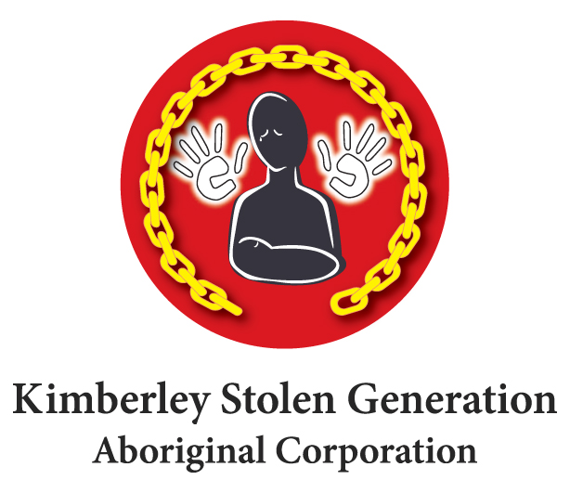
PO Box 2775 Broome WA 6725
Ph: (08) 9193 6502 or 1800 830 338
Fax: (08) 9193 5693
Email: admin@kimberleystolengeneration.com.au
ABN: 38 083 786 066 ICN: 3685

The Kimberley Stolen Generation Aboriginal Corporation is a community owned and controlled organisation that consists of members of the Stolen Generations and their families in the Kimberley region of Western Australia. The corporation offers activities, projects, and services that acknowledge the experiences of members of the Stolen Generations and help them come to terms with it. The corporation has a Link-Up Service that organises reunions and other activities for people of the Stolen Generation across the Kimberley. KSGAC also provides support services to victims of the Institutional Child Sexual Abuse through the Redress Scheme.

Receptionist / Admin Assistant
A position exists for a Receptionist / Admin Assistant located in Broome.

The role of Receptionist / Admin Assistant is to provide an efficient administration service relating to the services we deliver to our clients; to act as first point of contact for incoming calls and visitors to the facilities and ensure KSGAC is represented professionally at all times.
The successful candidate must have experience in office administration, strong computer skills, effective time management and excellent interpersonal and communication skills with the right attitude to work within a small organisation.

This position is subject to funding via the National Link-up program through the Department of Prime Minister & Cabinet.

How to apply
To obtain the selection documentation and application processes, please request a copy of the Applicant’s Job Pack by email: admin@kimberleystolengeneration.com.au

Should you require any further information regarding the position, please contact Sunny Liebermann on (08) 9193 6502 or 1800 830 338.

Applications close: Friday 19th October 2018

